AIR960

INSTRUCTION MANUAL
VHF AIR BAND TRANSCEIVER (FCC APPROVAL NUMBER GW2960 AIR)
INTRODUCTION
The AIR 960 handheld protable radio is a sophisticated, compact VHF synthesised transceiver.

It offers thumbwheel switch frequency selection with extremely good stability and accuracy.
AIR 960 has COM channel 118.000-136.975 MHz and NAV channels
108.000-117.975 MHz.

The radio meets tough environmental demands while providing cost effective, reliable communications.

PACKAGED CONTENTS
Check that your packaged content consists of the following:
- AIR 960 radio
- K-1120 12V 600mA sealed Ni-Cd power pack (attached to radio)
- Flexible Antenna
- Wall Charger
- Belt-Clip
- Hand-Strap
- Instruction Manual

OPTIONS
- Linear Amplifer Output 15-20 Watt Carrier
- Aviation Headset P.T.T. Adapter
- Aviation Headsets
- Aviation Intercom 2 or 4 Way
- Aviation Panel Mount Kit

CONTROLS, SWITCHES, INDICATORS AND CONNECTORS
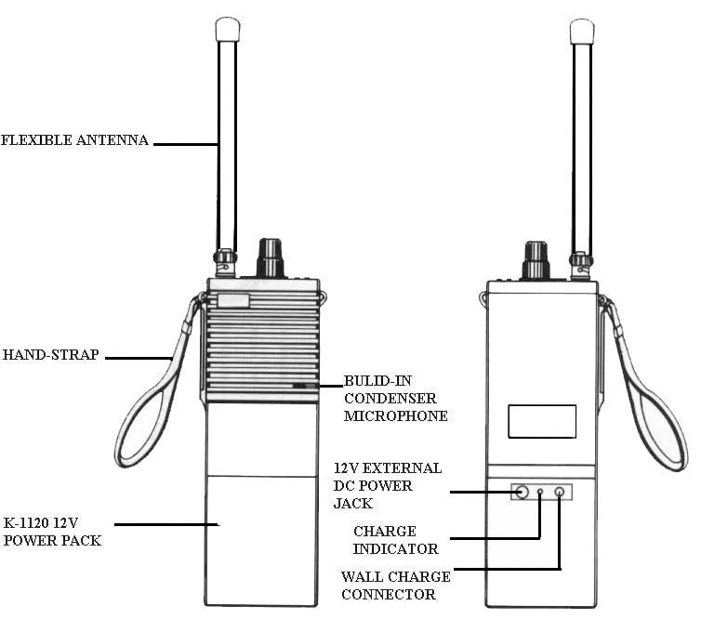
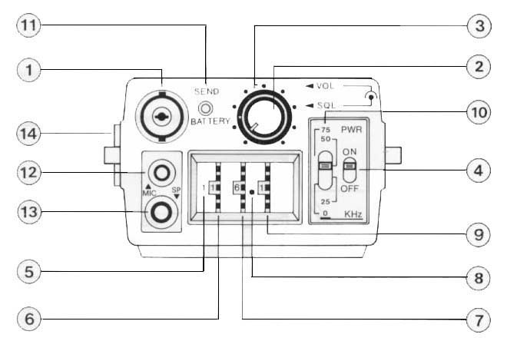
1. ANTENNA CONNECTOR | Connect the supplied flexible antenna.  CAUTION: Transmitting without an antenna  may damage the transmitter.
2. SQUELCH CONTROL  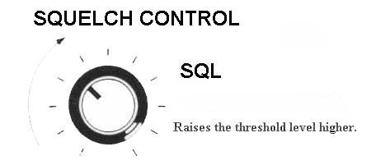 | Sets the squelch threshold level. Rotate this control  completely counterclockwise for minimal level squelsh  function, and clockwise to raise the threshold level.
3. VOLUME CONTROL  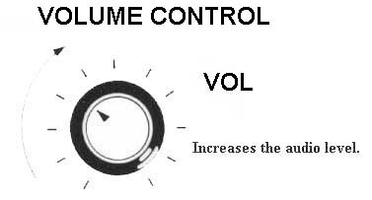 | Rotate this control completely counterclockwise to turn  the transceiver at minimal volume level. Rotate the  control clockwise to increase the audio volume level.
4. POWER SWITCH  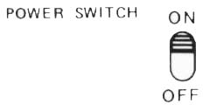 | Slide the switch to ON position to turn the transceiver  power on. Slide the switch to OFF position to turn the  transceiver power off.
5. 100 MHz INDICATOR | Indicates selected frequency set at 100 MHz range.
6. 10 MHz THUMBWHEEL SWITCH | Sets selected 10 MHz within the 108.000-136.975 MHz  frequency range.
7. 1 MHz THUMBWHELL SWITCH | Sets selected 1 MHz frequency.
8. DECIMAL POINT | Indicates for example 116.150 MHz frequency as shown  on diagram.
9. 100 KHz THUMBWHEEL SWITCH | Sets seleced 100 KHz frequency.
10. 0 KHz, 25 KHz; 50 KHz and 75 Khz  SLIDING SELECT SWITCH | Sets 0 KHz, 25 KHz, 50 KHz and 75 KHz frequencies.
11. TRANSMIT / BATTERY INDICATOR | Illuminates during the transmit mode. Also indicates the  battery condition during transmission. If indicator goes  out during transmission, stop using the transceiver  immediately. Arrange charging of the batteries.
12. EXTERNAL MIC JACK  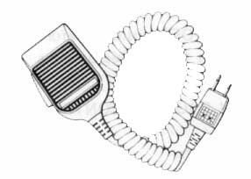 | If the use of an external microphone is desired, connect it to  this jack. When the external microphone is connected, the  built-in microphone will not function.  (The external speaker-microphone, an optional accessory can  be connected to this jack.)
13. EXTERNAL SPEAKER JACK | Connect an external speaker or earphone, if required to this  jack. Use a speaker with an impedance of 8 ohms. When the  external speaker is connected, the built-in speaker will not  function. (Or, connect the optional external speaker-  microphone as explained above.)
14. PUSH-TO-TALK (PTT) SWITCH | Push this switch to begin transmitting, Speak clearly with a  normal vocie into the microphone. The built-in microphone is  an electret condenser type which responds well to most voice  levels.
OPERATION
RECEIVING | Verify that the POWER SWITCH is in the OFF position  before connecting power to the transceiver. Attach the  flexible antenna or connecting an external antenna.  1. Rotate the VOLUME CONTROL and SQUELCH  CONTROL counter-clockwise to the minimal level.  2. Slide the POWER SWITCH to the ON position.  3. Slowly rotate the VOLUME CONTROL clockwise to a  comfortable level.  4. Select the desired frequency by rotating the appropriate  thumberwheel switches and SLIDING FREQUENCY  SWITCH.  5. If only noise with no signal is heard from the speaker, rotate  the SQUELCH CONTROL clockwise until the noise stops.  This is the threshold point. The transceiver remains silent after  this adjustment until a signal is received which opens the  receiver's squelch circuit. If very weak signals are received,  the squelch may open and close intermittantly. In this case,  rotate the SQUELCH CONTROL slightly further  clockwise until the squelch operates correctly.
TRANSMITTING | 1. Push the PTT (Push-To-Talk) switch and the transceiver  begins transmitting. At the same time the TRANSMIT/  BATTERY INDICATOR LED illuminates to indicate that  the transceiver is in the transmitting mode.  (If the indicator goes out during transmission, the batteries  are about exhausted, replace new batteries or stop using the  transceiver and charge the discharger batteries.)  2. Speak into the microphone using your normal voice level.  3. Release the PTT switch to return to the receive mode.

NOTE: If the frequency is accidentally set to a frequency outside the effective range of 118.000- 136.975
MHz during transmission, there will be no transmission. The PTT switch must be released before
resetting the effective frequency for transmission again. The same applies when an external
microphone only is connected, (this will put the transceiver into a constant transmitting mode) the
external microphone must be disconnected before resetting the frequency. The above will not apply if
working within the effective frequency range.

SAFETY INFORMATION

BATTERY
1. The sealed Ni-Cd power pack must be charged prior to use. For charging you may use the supplied wall
charger (charging time about 4-6 hours) or the optional desk top charger (charging time 1-2 hours) When
charging, turn the radio OFF or remove the power pack from the radio.

2. AVOID EXTERNAL SHORT-CIRCUITING OF THE BATTERY, which could premanently damage the
battery and create a fire hazard.

3. Never put batteries into a fire, an explosion could occur.

USE OF RADIO
1. Do not hold the radio with the antenna close to, or touching exposed parts of the body, especially the face
or eyes, while transmitting.
2. Do not hold the PTT switch on when not actually desiring to transmit.
3. Do not operate a transmitter near unshielded electrical blasing caps or in an explosive atmosphere.
4. Use of other power sources may be harmful and damage the radio.
5. This radio is not approved as a means of navigation.

SPECIFICATIONS
GENERAL
Number of Semiconductors | : Transistors 27  FETS 5  ICs 10  Diodes 39
Frequency Control | : PLL synthesizer with thumbwheel switch
Channel Spacing | : 25 KHz
Frequency Stability | : ±0.002% (-10℃~+50℃)
Antenna Impedance | : 50 ohms unbalanced
Power Supply Requirment | : 12Vdc
Current Drain at 12V | : Transmitting : Approx. 0.9A  Receiving : Stand by Appro. 80mA  Max. audio output Approx. 220mA
RECEIVER
Frequency Range | : 108.000-136.975 MHz
Receiving System | : Double-conversion superheterodyne
Modulation Acceptance | : A3E6K00 (6A3)
Sensitivity | : 108.000-117.975 MHz less than 2μV (6 dB S/N, 30%  Modulation)  118.000-136.975 MHz less than 1μV(6 dB S/N, 30%  Modulation)
Squelch Sensitivity  (with 50 ohm load) | : less than 1μV at threshold point at frequencies  higher than 118.000 MHz with 1KHz, 30% Modulation
Selectivity | : More than 60 dB at adjacent channel
Spurious Pesponse Rejection ratio | : More than 60 dB
Audio Output | : More than 500 mW
TRANSMITTER
Frequency Range | : 118.000-136.975 MHz
Output Power | : 1.5W carrier power (4.8W PEP)  ( ) shows PEP with 80% modulation by a 1 KHz  audio tone.
Emission mode | : A3E6K00 (6A3)
Modulation System | : Low level modulation
Spurious Emission | : More than 60 dB below carrier
Mircophone | : Built-in electret condenser microphone
Dimensions | : 5 x 2.5 x 1.5" Approx without battery
Weight | : 1.3 Lbs. or 500g

