Chris Ruf
04/25/21 #2762

I have a 1997 model Cobra trailer for my ASW-27.

I have just had what appears to be fatigue failure of the left rear latch attachment.
The extrusion has torn. Now the latch does not hold the top fully down.
Please see attached photos.

Can you suggest the best repair method?

If I remove the winglet attachment will there be easy access to the top side of this extrusion?
--
Chris
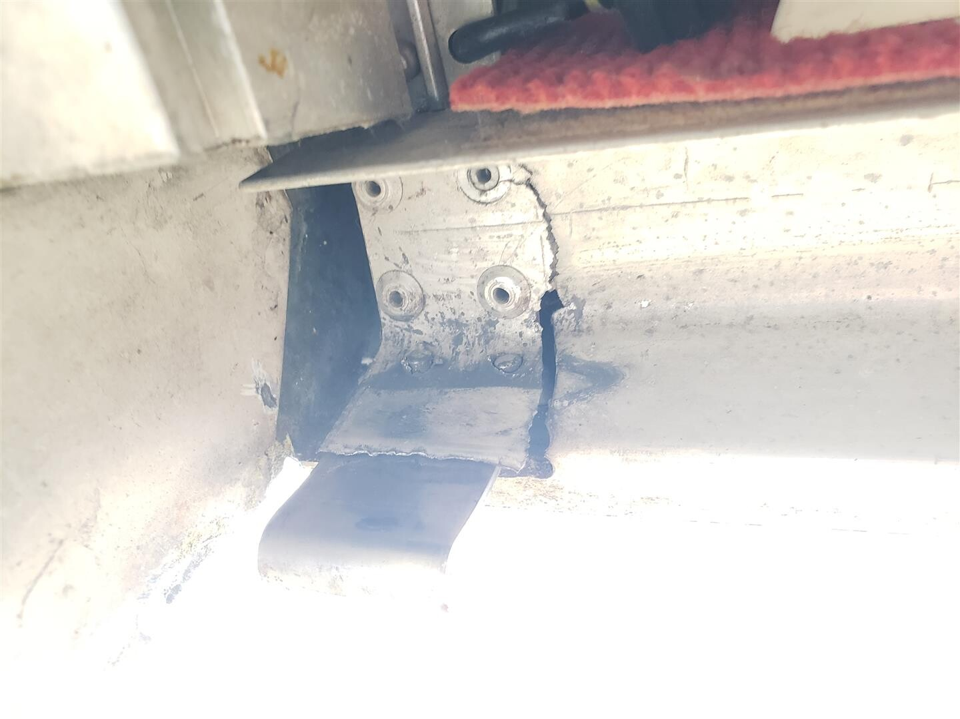
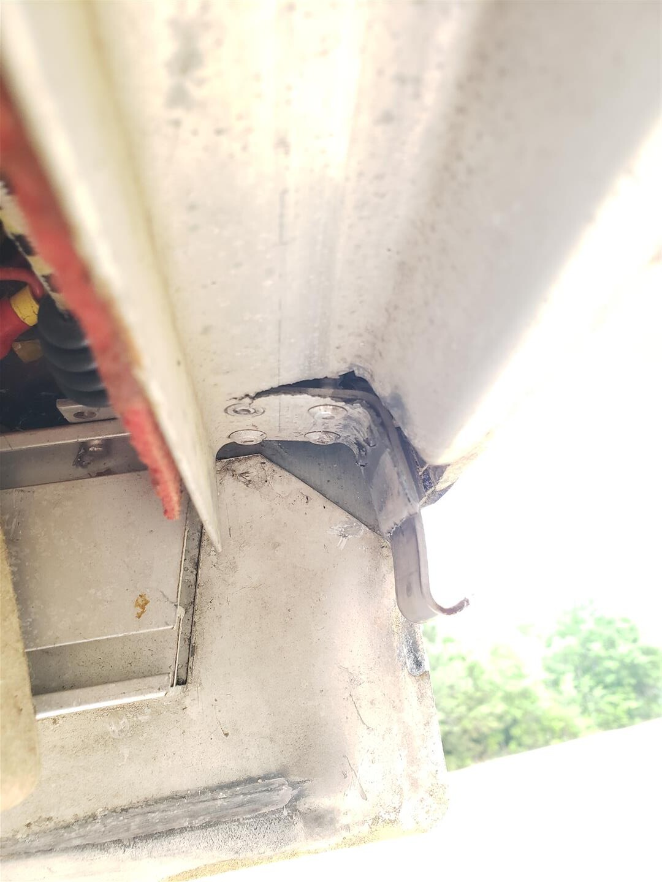
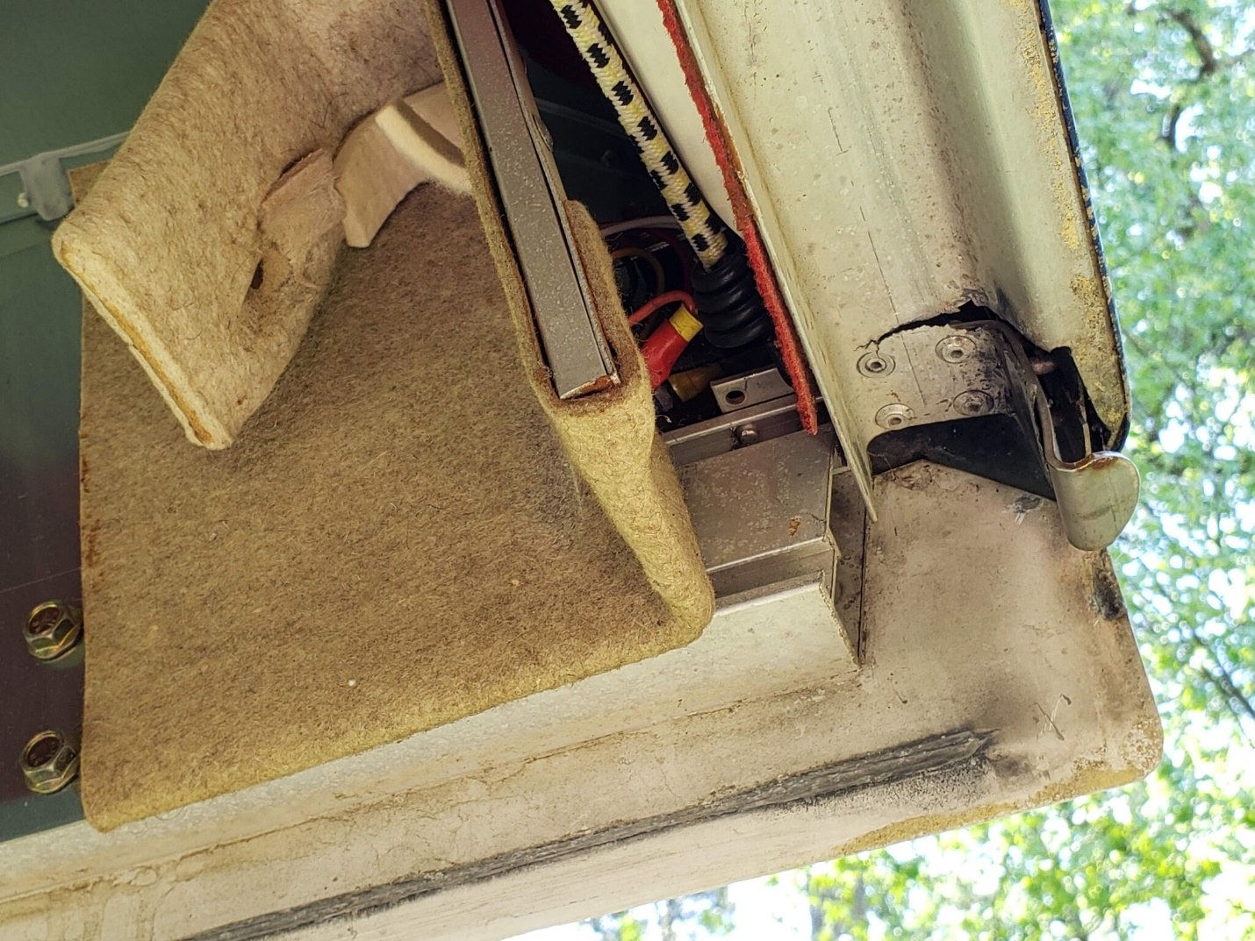
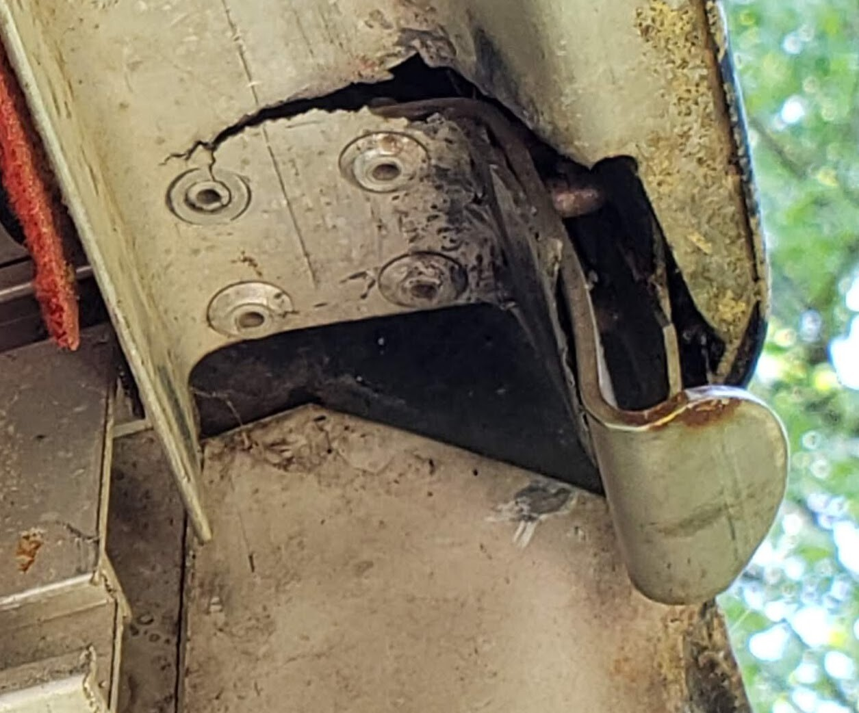
Reply
Like
More
HL Falbaum
04/25/21 #2765

Holy Smoke!~
How does the other side look?

I forget—your top is fiberglass, yes?

I expect you can get to the extrusion if you remove enough stuff.

It will need re-alignment, TIG (GTAW) welding, then re-enforcement.
Perhaps there is room for welded overlay re-enforcement from the bottom.
Same thickness as the extrusion.

If the lid is glass, could cut a hole for access to weld the re-enforcement on top of the extrusion..
Then replace the “hole”. They sometimes have to do this for a wing or fuselage repair.

It hints something is misaligned or the latch was too tight—perhaps?

Why re-invent the wheel? You may well not be the first ever.

Get advice from Cobra, Uncle Hank, John Murray, and Dave Nadler.

Hartley Falbaum
hfalbaum@...

toggle quoted messageShow quoted text
Reply
Like
More
SF
04/25/21 #2768

That is probably a 6061-T6 extrusion. Weld on it, and it becomes 1100 cast aluminum. Think bendy butter aluminum. Cant get it close to 6061 properties again without heat treatment. Might want to send Cobra an e-mail.
toggle quoted messageShow quoted text
Reply
Like
More
HL Falbaum
04/25/21 #2769

Of course you can't just butt weld it. Needs a backing plate. Use 5356 filler. Maybe rivet the backing plate with Cherrymax rivets.
Otherwise, replace the piece, may not have to do full length.
Major job for sure.

Sent from my Verizon, Samsung Galaxy smartphone

toggle quoted messageShow quoted text
Reply
Like
More
Chris Ruf
04/25/21 #2770

It is not a fiberglass top, all Aluminum.
The latch did not appear any tighter than the other side. They just pulled the top snug - but not much force.
I have emailed the factory, but wanted to know if anyone else had seen this. I showed the picture to Rex and Hank Nixon - it was a new one to them.
I think adding another layer of steel that goes inside the female extrusion on the lid will be a solution. The good news is that the lower sidewall with rubber gasket is less than 30mm wide. The Extrusion is 38mm wide at the narrowest point. If I add steel of about 2mm thickness I can make a U shaped section and the narrowest inside should be approximately 38-2-2=34mm, -1mm clearance so 33mm to fit the 30mm lower wall.
I like Scott's feedback to not try welding. Though adding a layer of JB Weld between the doubler and the existing part might help spread the load so the new rivets are not resisting all the force and vibration.
Chris
Chris
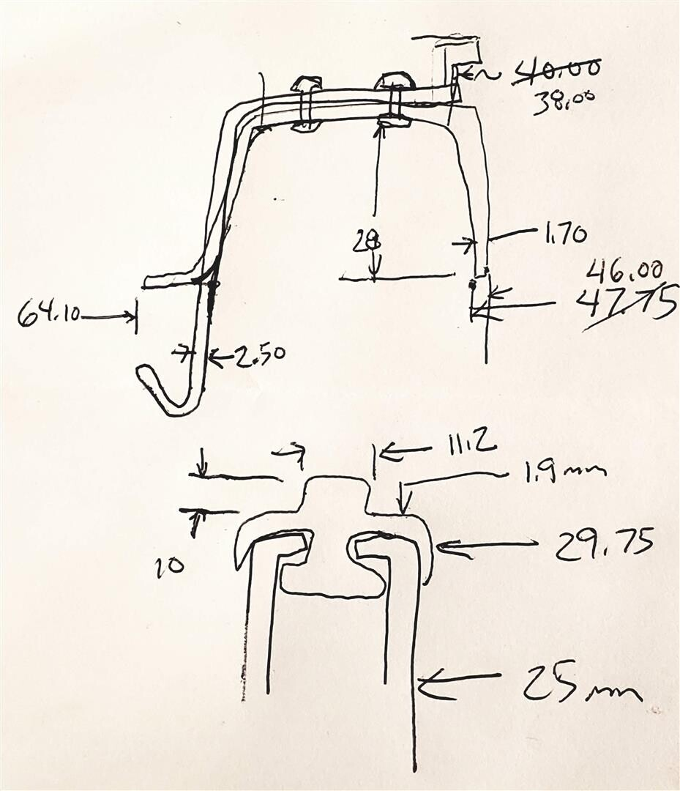
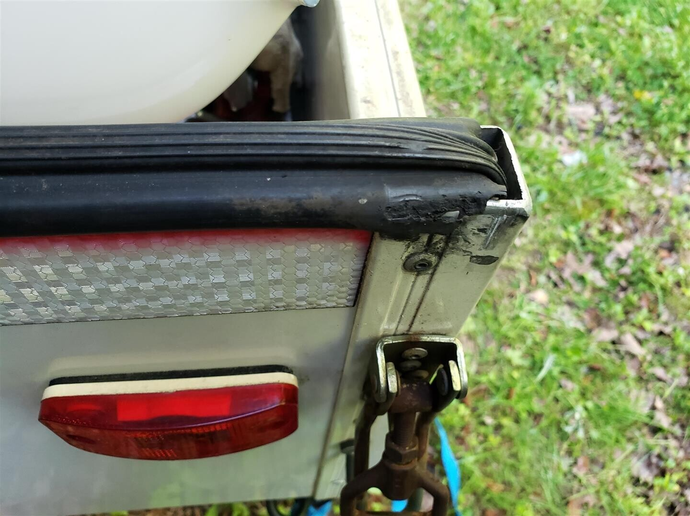
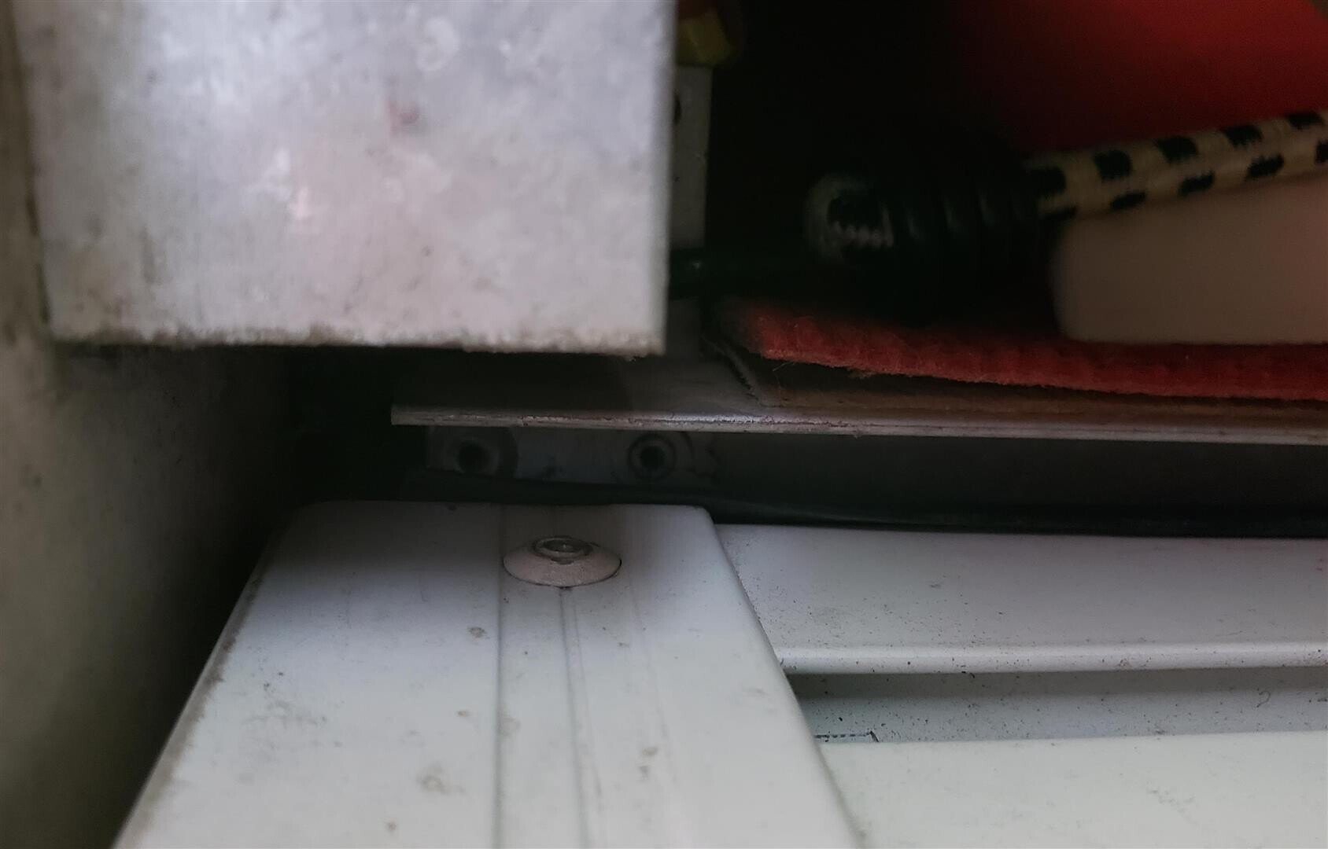
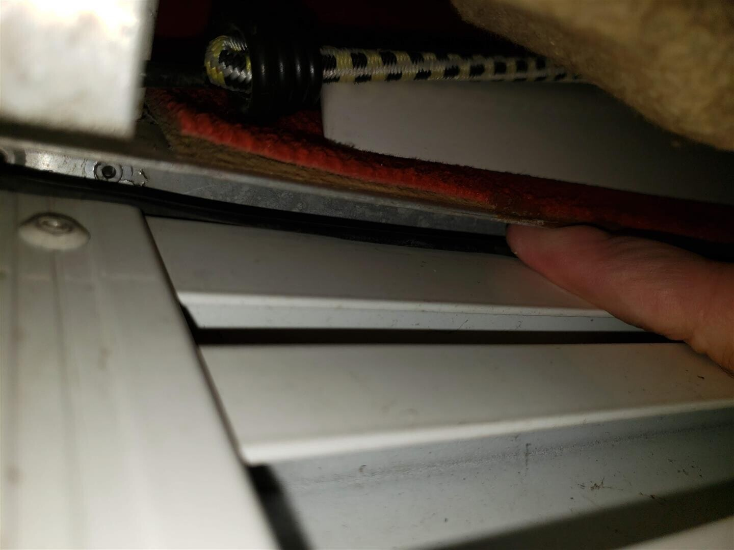
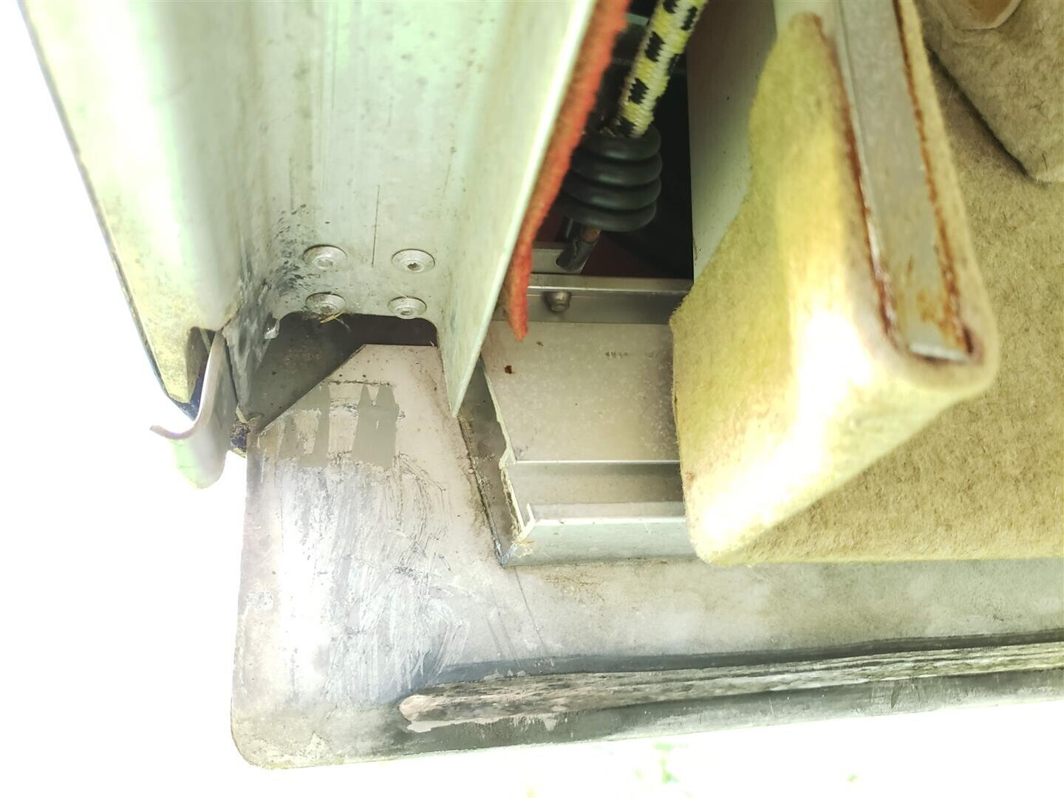
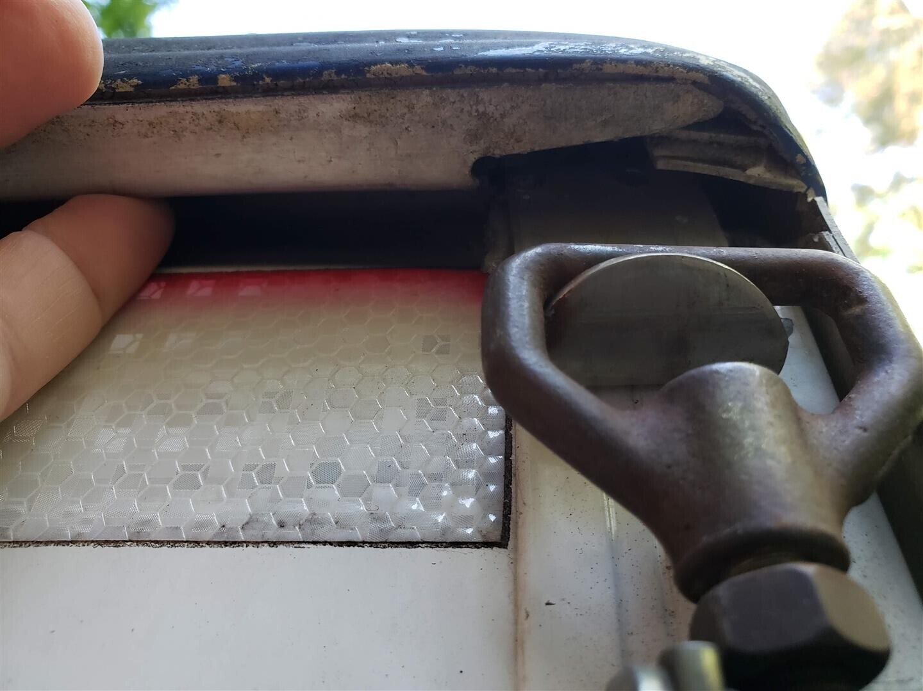
Reply
Like
More
HL Falbaum
04/25/21 #2773

OK, that changes things.

Looks like the other side is showing a beginning crack too.
I like your doubler idea. JB weld is good too. It can get brittle in time,
but with rivets doing the main job it should be OK.

I didn’t look closely enough at your seatback. There appears to be a horizontal crack a few inches below the “penetrations”

Yeah, a scarfing and glass job for sure. Perhaps instead of washers, a 1/16” thick steel disc or rectangle might be better.
The adjusting bolt should contact metal, so maybe glassing over it might not be the best idea.

Hartley Falbaum
hfalbaum@...

toggle quoted messageShow quoted text
Reply
Like
More
ONE IDAHO
6:08pm #2875

Chris, thank you for all your information. I "think" that a repair kit is coming from the factory? They have not been very communicative and W&W the Cobra dealer has done everything they can to get something coming my way. After spending a good amount of time researching the issue and looking at another Cobra trailer, mine is aluminum the other fiberglass top, I think I have found the week spot and suggest everybody with a Cobra look at this area. When the top is pulled down the latch goes to the outside of the bottom structure and rubs against the corner piece which is not beveled. This then rubs the heads off the two rivets that hold the latch to the outside of the top. With those heads gone all the force is on the top four rivets and the crack starts.My trailer a 2012 vintage has a very small crack started on the starboard side and both rivet heads on the side are gone. there is a good amount of wear on the top of the bottom corner piece showing the rubbing. The port side is not as bad but the rivet heads are almost gone. On the fiberglass trailer which is about 20 years old, the rivet heads are gone on both sides and there is wear on the bottom corner piece. This is a design issue. The bottom corner piece should be beveled! The gasket along the rail on the bottom does not cover the corner piece and would tear anyway as the top and bottom fit tightly and the the mechanism to hold the top down pulls the whole thin in tight to the bottom ... I have photos which I tried to post.
Boise Pilote

